**Sharing a Group Account in NoodleTools**

**Step 1 🡪** One person in your group should **login to NoodleTools and create a project**.

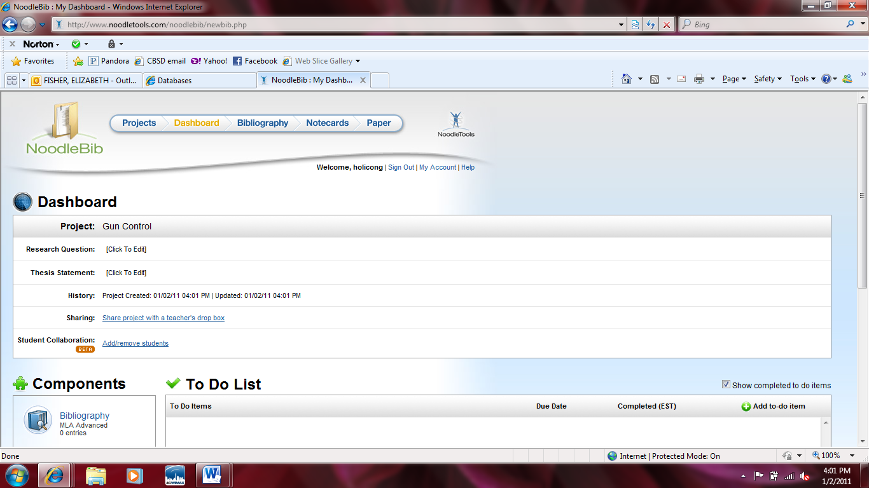**Step 2 🡪** On the dashboard, **click the Add/Remove students** link next to “Student Collaboration.”

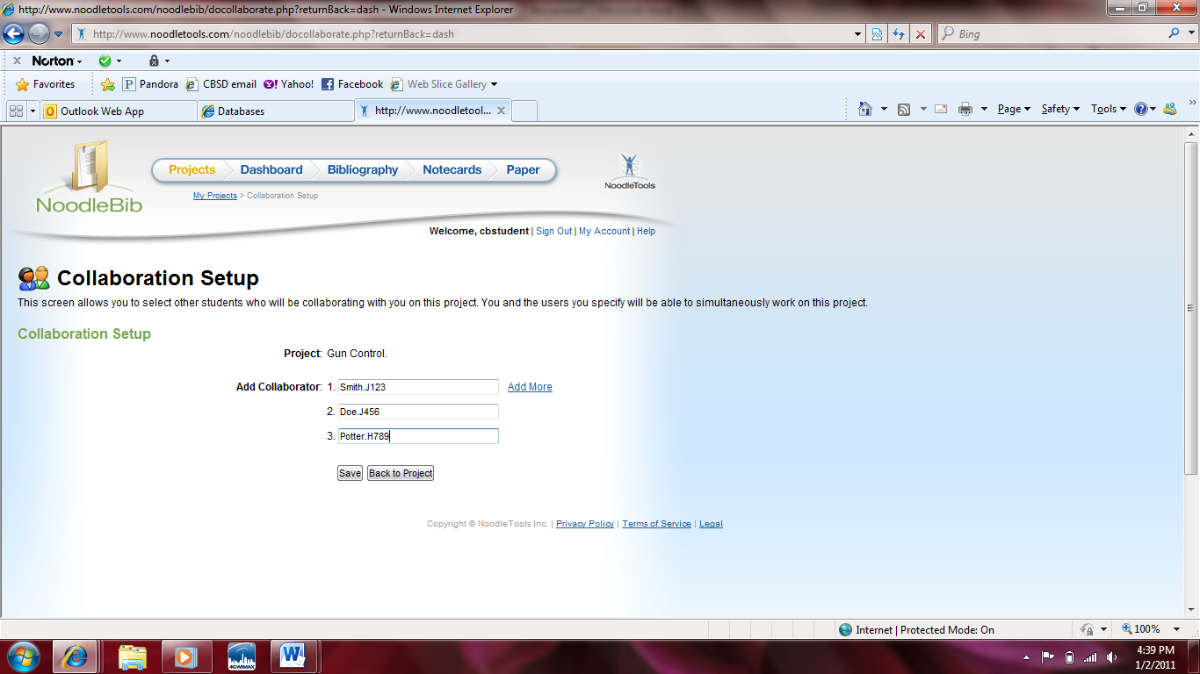**Step 3 🡪** Type in the **NoodleTools usernames for the other members of your** **group**

* Now everyone in your group has this NoodleTools project in their accounts. You can work on the project simultaneously and will be able to see the citations and notecards created by everyone in your group.*

**Sharing a Group Account in NoodleTools**

**Step 1 🡪** One person in your group should **login to NoodleTools and create a project**.

**Step 2 🡪** On the dashboard, **click the Add/Remove students** link next to “Student Collaboration.”

**Step 3 🡪** Type in the **NoodleTools usernames for the other members of your** **group**

* Now everyone in your group has this NoodleTools project in their accounts. You can work on the project simultaneously and will be able to see the citations and notecards created by everyone in your group.*